**SDS Exercise Report Group 11**

**12151302 이해성 12151310 장효준 12171479 김현진 12181465 김재욱**

**1. Introduction**

What the final assignment requires is that making a software-defined storage database system written in C language using MySQL database. Thus, the final result is a software working on prompt terminal that must have an UI for users as well as supervisors and functions monitoring database and for managing personal files. The function we have implements are …

**\* Common**

1. User Interface (UI)

**\* Users**

1. Modifying file status in database (uploading, deleting).

2. Showing tables to let them know what they have uploaded.

3. Showing tables sorted as which they want as. (FileID, DataPath, ModifyTime, FileSize)

4. Finding files.

**\* Supervisor**

1. Changing filename extension type to prevent users from uploading other files except for defined one.

2. Changing file size that limits the maximum file size uploaded on the database by users.

3. User status.

4. Getting information about free space, used space and total space.

All the works are tested and managed inside of our database. Because to use ‘Trigger’ function, there must be an authorization. However, the environment that professors gave us, ‘Trigger’ isn’t permitted and this is why we highlight the reason for using our database.

**2. ER Diagram**

We made total 4 tables and tuples some tables inside, ‘BigFiles’, ‘SmallFiles’, are automatically inserted and deleted by trigger based on ‘MetaData’ table. One thing about our tables is that all of them are related each other but there aren’t any foreign keys and constraints.

**2-1. Relations and Attributes**

|  |  |
| --- | --- |
| Relations | Attributes |
| users | UserID, UserName, UserPW, SV |
| MetaData | FileID, FileName, Filesize, ModifyTime, UserID |
| BigFiles | bigFileID, FileID, DataPath, UpdatedCount, HOT, UserID |
| SmallFiles | smallFileID, FileID, DataPath, UpdatedCount, HOT, UserID |

**2-2 Triggers**

As mentioned earlier, tables are related but be with trigger function. Trigger is a kind of automatic function that updates tuples in selected table based on the condition inside. Trigger we used are..

1. When user uploads the file, a new tuple is inserted into MetaData table. When new update in MetaData table noticed, then other tuple is inserted into either BigFile table or SmallFile table based on file size.
2. When users deleted the file, all the tuples related to the file inserted earlier into each table are deleted automatically deleted.
3. When user updates the file, Modify time is changes but also update count increases as well. Trigger automatically checks the update count, and updates ‘HOT’ value of the tuple.

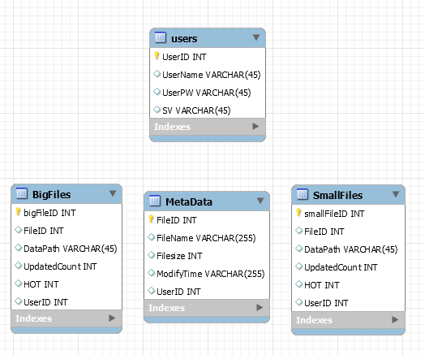**2-3 ER Diagram**

As you may notice, there are not any foreign keys but triggers.

**3. Specification**

All functions we implemented are shown in the video attached in the zip archive.

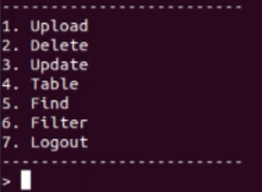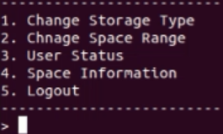**3-1. User interface**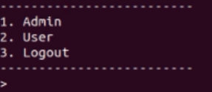

**LEFT : Menu, MIDDLE : Supervisor Interface, RIGHT : User Interface**

Supervisor is assigned by ‘SV’ value in users table. Only supervisor has a value of 1 in SV attribute others does null. Both supervisor and users can fully use the database as shown in the pictures.

**3-2. Supervisor**

**3.2-1. Change Storage Type**

Supervisor can prevent users from uploading other file that violates defined filename extension by configurating storage type. Default is ‘.txt’ which means users are only able to upload text files on the database.

**3.2-2. Change Space Range**

Supervisor can set the maximum file size that users can upload.

**3.2-3. User Status**

Supervisor can monitor the user status. User status is kind of ambiguous because it could give supervisor information about the user or files that user uploaded. We implemented former and this included supervisor him/herself as well.

**3.2-4. Space Information**

Supervisor can monitor the information of the database space. Total Space is ‘10240000’ which we virtually set. Supervisor can see how much used space and free space are.

**3.3 Users**

**3.3-1. Upload**

Users can upload a file by using this feature. They can continuously upload the files that fulfil all the requirement supervisor set earlier until they type ‘exit’.

**3.3-2. Delete**

Users can delete a file by using this feature. When the delete a file, all the tuples related to the file in the tables are automatically deleted by ‘Trigger’ function in MySQL.

**3.3-3. Update**

Users can update their file by typing file name they want to make new. Modify time and Hot value are updated by ‘Trigger’ function.

**3.3-4. Table**

Users can watch the table which is about the files they uploaded. They only can see the files they uploaded, not others’.

**3.3-5. Find**

Users can find the file by typing file name. They would get information about the file if had been uploaded through this feature.

**3.3-6 Filter**

Users can watch the table sorted as they typed. Only suggested orderings are able.

**4. Analysis**

1) Error with creating trigger

Error Message : You are using safe update mode and you tried to update a table without a WHERE that uses a KEY column.

Explain : When we perform ‘update’ and ‘delete’ at the table, we need to update or delete only rows that satisfy the condition using ‘where’.. This error is occurred when we use attributes’ value other than a key value. So we perform set sql_safe_updates=0; before performing query to perform ‘safe update’ temporarily.

2) Error with applying trigger

Error Message : ERROR 1419 (HY000): You do not have the SUPER privilege and binary logging is enabled (you *might* want to use the less safe log_bin_trust_function_creators variable)

Explain : This error is occurred when we apply trigger query after connecting to 18.191.115.214 using Putty. When editing data at the database, data inconsistencies between slave can be a serious problem, so master occurs error to protect the process. We connected by remote control, so we don’t have super right. So we make it ‘root right’ so that the user can perform a stability check about function using “ SET Global log_bin_trust_function_creators='ON' “. But we don’t have super right, because only the user who make server has super right. So we create a new database by ‘Ubuntu’ to get the super right.